Components of a Mail Server System

📬 Components of a Mail Server System
# Source: AI Source: Provided by: [Data Path: Persons Table -> ID Column: 1, Name_En Column: Motasem Essam] -> From: [Chatgpt (GPT‑5 Mini)] on [1/21/2026]
A Mail Server System is made up of several software components that work together to send, receive, deliver, and store email messages.
Here’s a breakdown of the main components and what each one does:

🧩 1. Mail User Agent (MUA) – Email Client
# Source: AI Source: Provided by: [Data Path: Persons Table -> ID Column: 1, Name_En Column: Motasem Essam] -> From: [Chatgpt (GPT‑5 Mini)] on [1/21/2026]
- What it is: The software used by a person to read and send email.
- Examples: Outlook, Thunderbird, Gmail (webmail), Apple Mail.
- Protocol used: IMAP, POP3, SMTP.
🧠 Think of it as: “The app where users check their inbox.”

🧩 2. Mail Transfer Agent (MTA) – Outgoing Mail Router
# Source: AI Source: Provided by: [Data Path: Persons Table -> ID Column: 1, Name_En Column: Motasem Essam] -> From: [Chatgpt (GPT‑5 Mini)] on [1/21/2026]
- What it is: The core server that relays email from the sender to the recipient's server.
- Examples: Postfix, Exim, Sendmail, Microsoft Exchange.
- Protocol used: SMTP.
🧠 Think of it as: “The post office that moves mail between cities.”

🧩 3. Mail Delivery Agent (MDA) – Local Delivery
# Source: AI Source: Provided by: [Data Path: Persons Table -> ID Column: 1, Name_En Column: Motasem Essam] -> From: [Chatgpt (GPT‑5 Mini)] on [1/21/2026]
- What it is: Responsible for receiving email from the MTA and delivering it to the local mailbox on the server.
- Examples: Dovecot (also acts as IMAP/POP server), Procmail, Maildrop.
- Protocol used internally: Local system paths like Maildir or mbox.
🧠 Think of it as: “The person who puts mail in your physical mailbox.”

🧩 4. IMAP/POP3 Server – Mail Access
# Source: AI Source: Provided by: [Data Path: Persons Table -> ID Column: 1, Name_En Column: Motasem Essam] -> From: [Chatgpt (GPT‑5 Mini)] on [1/21/2026]
- What it is: Allows the user (MUA) to fetch and read emails from the server.
- Examples: Dovecot, Courier, Cyrus.
- Protocols:
  - IMAP (Internet Message Access Protocol): Keeps messages on the server (syncs multiple devices).
  - POP3 (Post Office Protocol v3): Downloads and usually deletes mail from the server.
🧠 Think of it as: “The tool that lets you check your mail remotely.”

🧩 5. Mail Storage – Mailbox System
# Source: AI Source: Provided by: [Data Path: Persons Table -> ID Column: 1, Name_En Column: Motasem Essam] -> From: [Chatgpt (GPT‑5 Mini)] on [1/21/2026]
- What it is: The file format and location where emails are physically stored.
- Formats:
  - Maildir/ (one file per message)
  - mbox (all emails in one file)
🧠 Think of it as: “The filing cabinet that holds all your letters.”

🧩 6. DNS with MX Records – Email Routing
# Source: AI Source: Provided by: [Data Path: Persons Table -> ID Column: 1, Name_En Column: Motasem Essam] -> From: [Chatgpt (GPT‑5 Mini)] on [1/21/2026]
- What it is: The system that tells the internet which server is responsible for receiving email for a domain.
- Record type: MX (Mail Exchanger)
🧠 Think of it as: “The address directory for mail servers.”

Optional Components
# Source: AI Source: Provided by: [Data Path: Persons Table -> ID Column: 1, Name_En Column: Motasem Essam] -> From: [Chatgpt (GPT‑5 Mini)] on [1/21/2026]
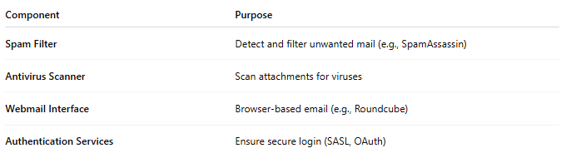
Component | Purpose
Spam Filter | Detect and filter unwanted mail (e.g., SpamAssassin)
Antivirus Scanner | Scan attachments for viruses
Webmail Interface | Browser-based email (e.g., Roundcube)
Authentication Services | Ensure secure login (SASL, OAuth)

🧠 Visual Summary
# Source: AI Source: Provided by: [Data Path: Persons Table -> ID Column: 1, Name_En Column: Motasem Essam] -> From: [Chatgpt (GPT‑5 Mini)] on [1/21/2026]
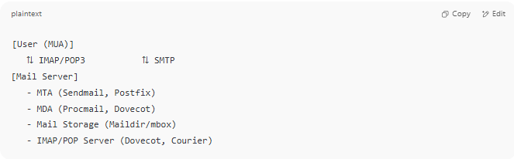

[User (MUA)]
⇅ IMAP/POP3 ⇅ SMTP
[Mail Server]
- MTA (Sendmail, Postfix)
- MDA (Procmail, Dovecot)
- Mail Storage (Maildir/mbox)
- IMAP/POP Server (Dovecot, Courier)

✅ Summary
# Source: AI Source: Provided by: [Data Path: Persons Table -> ID Column: 1, Name_En Column: Motasem Essam] -> From: [Chatgpt (GPT‑5 Mini)] on [1/21/2026]
A complete mail server system includes:
- MUA: The client
- MTA: Sends email
- MDA: Delivers to local inbox
- IMAP/POP3 Server: Lets users access their inbox
- Mailbox Storage: Where the mail is saved
- MX DNS Records: Helps route mail across the internet

